Athletic Event Procedures
Visiting Team Reference Guide



Spring Sports
2023-2024

We at Duncan Public Schools welcome you, your staff, your athletes, and your fans to our school. We have prepared this packet as an easy way to get to know our staff, our facilities, and our procedures. As always, our ultimate goal is to provide a safe environment for our athletic events.
In this packet, you will find our athletic Emergency Action Plan, our Standard Response Protocol, and a list of contacts that you may find helpful. With regard to your specific event, this packet may include individualized information as needed.
Duncan High School Basketball games are held at the High School Gymnasium, which is located directly north of the High School.
Duncan High School Wrestling events are held at both the Duncan High School Gymnasium and the Hoover Wrestling Center. The Hoover Center is located 212 North 9th Street.
Bus parking for events at the Gymnasium Buses is located across to the south in the gated parking lot directly south of the church. Please do not park in the church parking lot. For events at the Hoover Center, buses may park in the church parking lot at the southwest corner of 9th and Ash Streets.
Security for Duncan Public Schools events is provided by members of the Duncan Police Department. Officers will be posted throughout the location. These officers are present for the safety of everyone present, and are happy to help with any concerns.
Members of Administration traveling with the team should make contact with the Athletic Director or another member of the DHS Administration team on arrival. Please provide adequate administrative staffing to assist with your visiting team needs.
Thank you for helping us make Duncan a safer place for all of us.

CONTACT LIST

Athletic Director Bobby Cook 580-606-1621
DHS Principal Lisha Elroy 580-606-0401
DHS Asst Principal Kevin Kelly 580-467-1118
DHS Asst Principal Rodney Strutton 580-475-5247
DHS Boys Coach Zac Knox 405-990-1477
DHS Girls Coach Grant Givens 580-656-2666
DHS Wresting Coach Ashton Cooper 404-545-0777
DHS Athletic Trainer Amanda Woods 580-467-8872
DHS School Resource Officer Dustin Smith 580-467-6319

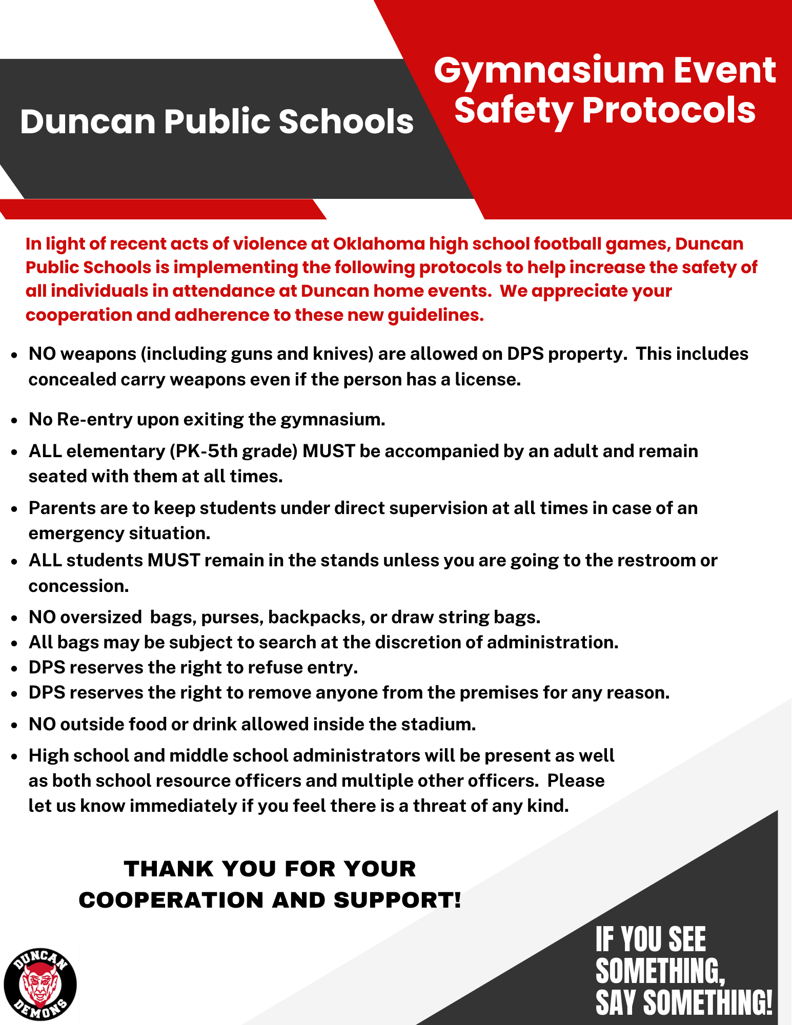
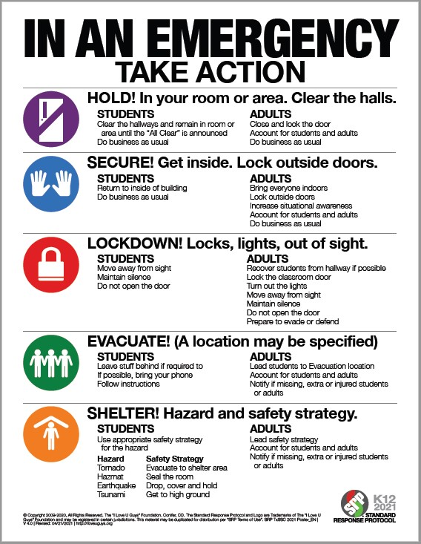

Duncan High School Winter Sports
Inclement Weather Protocol

Duncan High School Gymnasium

In the event of a tornado warning or impending dangerous weather, teams, officials and spectators will take shelter in the Black Box Theater located on the south end of the high school campus. In the event that there is insufficient time to reach that location, shelter will be taken in the basketball locker rooms located in the inner part of gymnasium.

Hoover Wrestling Center

In the event of a tornado warning or impending dangerous weather, teams, officials and spectators will take shelter in the visitor’s locker rooms.

Emergency Action Plan
For Duncan High School
Athletics Program

In case of an emergency, personnel responsibilities, locations of emergency equipment, and other emergency information such as 911 call instructions, addresses/directions to the venue, and a chain of command with important phone numbers have been listed here.

Personnel Involved in Development

The following individuals were involved with the creation of this Emergency Action Plan:
Amanda Woods, ATC, LAT (Athletic Trainer)
Survival Flight, Inc (Ambulance Services)

EMERGENCY ACTION PLAN FOR ATHLETICS
OVERVIEW

Introduction
Emergency situations may arise at any time during athletic events. Expedient action must be taken in order to provide the best possible care to the student athlete. The development and implementation of an emergency action plan will help ensure that the best care will be provided.
As emergencies may occur at any time and during any activity, all school activities personnel must be prepared. Athletic organizations have a duty to develop an emergency action plan that may be implemented immediately when necessary and provide appropriate standards of emergency care to all sports participants. This preparation involves formulation of an emergency action plan, proper coverage of events, maintenance of appropriate emergency equipment and supplies, utilization of appropriate emergency medical personnel, and continuing education in the area of emergency medicine and planning. Through careful pre-participation physical screenings, adequate medical coverage, safe practice and training techniques and other safety avenues, some potential emergencies may be averted. However, accidents and injuries are inherent with sports participation, and proper preparation on the part of the sports medicine team should enable each emergency situation to be managed appropriately and efficiently.
Components of an Emergency Action Plan
- Emergency Personnel
- Emergency Communication
- Emergency Equipment
- Roles of First Responder
- Venue Directions with a Map
- Emergency Action Plan Checklist for Non-Medical Emergencies

Emergency Personnel
The first responder in an emergency situation during an athletic practice or competition is typically a member of the sports medicine staff, such as a certified athletic trainer. However, the first responder may also be a coach or another member of the school personnel.
Certification in cardiopulmonary resuscitation (CPR), first aid, automated external defibrillator (AED), emergency action plan review, and prevention of disease transmission, and emergency plan review is required for all athletics personnel associated with practices, competitions, skills instructions, and strength and conditioning [including: athletic director, school nurse, certified athletic trainer, all coaches, etc.]. Copies of training certificates and/or cards should be maintained with the athletic director. All coaches are required to have CPR, First Aid, AED, and concussion management training certifications.
The emergency team may consist of physicians, emergency medical technicians, certified athletic trainers, athletic training students, coaches, managers, and possibly even bystanders. Roles of these individuals will vary depending on different factors such as team size, athletic venue, personnel present, etc.
The four basic roles within the emergency team are:
Establish scene safety and immediate care of the athlete:This should be provided by the most qualified individual on the medical team (the first individual in the chain of command).
Activation of Emergency Medical Services:This may be necessary in situations where emergency transportation is not already present at the sporting event. Time is the most critical factor and this may be done by anyone on the team.
Equipment Retrieval:May be done by anyone on the emergency team who is familiar with the types and locations of the specific equipment needed.
Direction of EMS to the scene:One of the members of the team should be in charge of meeting the emergency personnel as they arrive at the site. This person should have keys to locked gates/doors.

Activating Emergency Medical Services
Call 9-1-1
Provide information
Name, address, telephone number of caller
Nature of the emergency (medical or non-medical)*
Number of athletes
Condition of athlete(s)
First aid treatment initiated by first responder
Specific directions as needed to locate the emergency scene (i.e. “use the south entrance to the school off Asylum St.”)
Other information requested by the dispatcher
DO NOT HANG UP FIRST
*if non-medical, refer to the specified checklist of the school’s non-athletics emergency action plan

Emergency Communication
Communication is key to a quick, efficient emergency response. There is a pre-established phone tree to ensure all relevant parties are notified. Access to a working telephone line or other device, either fixed or mobile, should be assured. There should also be back-up communication in effect in case there is a failure of the primary communication. At every athletic venue, home and away, it is important to know the location of a workable telephone. Please see page 11 for emergency communication guidelines for Duncan High School.
Medical Emergency Transportation
Any emergency situation where there is loss of consciousness (LOC), or impairment of airway, breathing, or circulation (ABCs) or there is a neurovascular compromise should be considered a “load and go” situation and emphasis is placed on rapid evaluation, treatment, and proper transportation. Any emergency personnel who experiences doubt in their mind regarding the severity of the situation should consider a “load and go” situation and transport the individual.

Non-Medical Emergencies
For the non-medical emergencies (fire, bomb threats, violent or criminal behavior, etc.) refer to the school emergency action plan and follow instructions.
Post EAP Activation Procedures:
Debriefing
A team consisting of the ATC, AD, coaches, nurse and one or two other school district employees not involved with the situation must discuss the event within 48 hours. This team must evaluate the effectiveness of the EAP and conduct a staff debriefing. A specific timeline for changes to EAP should be made for promptness.

Conclusion
The importance of being properly prepared when athletic emergencies arise cannot be stressed enough. An athlete’s survival may hinge on the training and preparation of healthcare providers. It is prudent to invest in athletic department “ownership” in the emergency action plan by involving the athletic administration and sport coaches as well as sports medicine personnel. The emergency action plan should be reviewed at least once a year with all athletic personnel and local emergency response teams. Through development and implementation of the emergency plan Duncan High School helps ensure that the athlete will have the best care provided when an emergency situation does arise.

Staff Education
- Each season, every coach will receive a copy of the Emergency Action Plan (EAP)
  - Each coach will provide their signature to confirm they have read the documents and asked any potential questions
- A copy of the EAP will be posted on the wall in the athletic training room.

Chain of Command
The Athletic Trainer should always act as primary care-giver at the site of the injury or accident (when on-site) and would manage the situation according to the following rank:
- Amanda Woods, ATC, LAT (Athletic Trainer)
- Danny Giles, MD (Team Physician)
- Bobby Cook (Athletic Coordinator)/Dr. Channa Byerly (Superintendent)
- Lisha Elroy, Kevin Kelly, Rodney Strutton (Administrators)
- Head Coach
- Assistant Coach
In the event that a certified athletic trainer is not on-site at the time of injury the following chain of command would be used:
- Danny Giles, MD (Team Physician)
- Bobby Cook (Athletic Coordinator)/Dr. Channa Byerly (Superintendent)
- Lisha Elroy, Kevin Kelly, Rodney Strutton (Administrators)
- Head Coach
- Assistant Coach

Emergency Telephone Numbers
This list is only to be used in case of an emergency.
Off Campus Contacts | Phone Number
Emergency | 911
Police department | 911
Fire and Ambulance | 911
Duncan Regional Hospital | (580) 252-5300
Poison Control Center | 1-800-222-1222

On Campus Offices | Phone Number
Athletic Training Room | Amanda Woods (580) 467-8872
Athletic Coordinator | (580) 255-4366 x266
Head High School Principal | (580) 255-0700
DHS Main Office/Nurse Office | (580) 255-0700
Administrative Office | (580) 255-0686
School Counselor Office | (580) 255-0700

Title | Name | Office | Cell
Athletic Trainer | Amanda Woods | (580) 467-8872 | (580) 467-8872
Athletic Director  Superintendent | Bobby Cook  Dr. Channa Byerly | (580) 255-4366 | (580) 606-1621  (580) 656-4424
Principal | Lisha Elroy | (580) 255-0700 | (806) 606-0401
Assistant Principal | Kevin Kelly | (580) 255-0700 | (580) 467-1118
Assistant Principal | Rodney Strutton | (580) 255-0700 | (580) 475-5247
Nurse | Tabitha Sale | (580) 255-0700

Emergency Situation Contact Tree

Injury or Sudden Illness
First Responder on the Scene
CARE
Life Threatening Condition

[1a] CALL
911
*Have [1b] get the AED
Call Parent/Guardian
Call Athletic Trainer
Call Athletic Director

Call
Athletic
Trainer

Provide care until EMS arrives.
Do not leave victim.

Provide proper first aid and care until athletic trainer arrives.
Do not leave victim.
CARE
CARE
CARE
Non-Life Threatening Condition
CHECK
Call Principal
(if warranted)

1a: first to respond, bystander, coach, administrator
1b: bystander, coach, administrator
After the situation is controlled: Call Athletic Director and/or Principal
Athletic Trainer may at their discretion contact sports medicine physician for guidance.

Emergency Equipment Locations
Emergency Equipment:
- Athletic Training Kit, Splint Kit on site for events covered by Athletic Trainer
- First Aid Kit located with coach
      - AED
        - Located with ATC for all covered events
        - Located in each of the DHS athletic facilities (see map)
      - Nearest phone
        - Athletic Trainer’s personal cell phone when covering events
        - Administrator on Duty’s personal cell phone when covering events
        - Coaches’ personal cell phones
      - Rescue Inhaler
        - Coaches are responsible for each student who has an inhaler and is responsible for bringing the inhaler with them to all practices/games
        - Inhaler must be left with coach (labeled with name) during practices and games (not left in personal bag)
        - Athletic trainer may be given a backup inhaler by the parent or child to keep as a backup in the med kit.
      - Epi Pen
        - Coaches are responsible for each student who has an epi pen and is responsible for bringing their epi pen with them to all practices/games
        - Epi pen must be left with coach (labeled with name) during practices and games (not left in personal bag)
        - Athletic trainer may be given a backup Epi pen by the parent or child to keep as a backup in the med kit.
      - Splints
        - With Athletic Trainer during events or in Athletic Training Room
      - Spine boards/Cervical Collar
        - Will be provided by EMS upon arrival
      - Bio-hazard Materials
        - Red bags – In Athletic Trainer’s med kit or in Athletic Training Room

Duncan High School AED Locations

Duncan High School Gym: AED located in Main Gymnasium on the wall on the SW Corner of the court. West of Home Side Stands.

Duncan High School Football Stadium: AED located in the Training Room, which is the first door south of the Home Side Stands. During events where the Athletic Trainer is present the AED is on the sidelines.

Duncan High School Hoover Wrestling Facility: AED located on the SE Corner of the Main Gym

Duncan High School Baseball Field: AED located in the Coach’s office inside the locker room. The building south of the field.

Duncan Softball Field: AED is located on the wall just inside the door of the building behind the stands.

Duncan Tennis Courts: No AED located at this location at this time.


General Plan of Action
- Most medically qualified person will lead
- Check the scene – is it safe to help?
- Is the athlete breathing? Conscious? Pulse?
  - If NO instruct person to call 911 – LOOK PERSON DIRECTLY IN EYES and MAKE SURE THEY CALL!!!
  - Check the 911 call instructions for your location
- Perform emergency CPR/First Aid
  - If severe bleeding – instruct individual to assist with bleeding control
- Instruct coach, administrator or bystander to get AED
- Instruct coach, administrator or bystander to control crowd
- Contact the Athletic Trainer of Duncan High School if they are present at the school but not on scene
- Contact parents
- Contact Athletic Director
- Contact Principal/Assistant Principal
- Instruct an individual to meet ambulance to direct to appropriate site
- Assist with care as necessary
- Assistant coach must accompany athlete to hospital – either in ambulance or follow by car
- Debrief the event

Duncan High School

Emergency Action Plan

Gym
Activate the EAP:
- Any loss of consciousness
- Possible Spine Injury
- Dislocation, Open Fracture, Displaced Closed Fracture
- Difficulty or absent breathing or pulse
- Uncertainty of if you have a medical emergency
Emergency Personnel:
Duncan High School Athletic Trainer will be on site for select practices and events or in direct communication with coaching staff. Emergencies during practices/games where Athletic Trainer is not present. EMS should be contacted immediately.

Emergency Procedures:
- Check the scene
  - Is it safe for you to help?
  - What happened?
  - How many victims are there?
  - Can bystanders help?
- Instruct coach or bystander to call 911
-Provide the following information
- Who you are
- General information about the injury or situation
- Where you are (Provide: name, location of downed athlete, address, telephone #, number of individuals injured, type of injury that has occurred, treatment given, specific directions*).
Duncan High School Gym
515 North 19th Street
*EMS should be instructed to enter gym through main lobby doors
- Any additional information
- *STAY ON THE PHONE, BE THE LAST TO HANG UP*
- Perform emergency CPR/First Aid
  - Check airway/breathing/circulation, level of consciousness, and severe bleeding.
    - If athletic trainer is present he/she will stay with athlete and provide immediate care.
    - If athletic trainer is not present, most qualified coach (training/certifications) will stay with athlete and provide immediate care.
  - Instruct coach or bystander to GET AED!!
- Designate coach or bystander to control crowd
- Contact the Athletic Trainer for Duncan High School if not present on scene
- Meet ambulance and direct to appropriate site
  - Open Appropriate Gates/Doors
  - Designate an individual to "flag down" and direct to scene
  - Control injury site, limit care providers etc.
- Assist Athletic Trainer and/or EMS with care as directed
  - Retrieve Necessary Supplies/Equipment
- An assistant coach must go with the athlete to the hospital or follow in a car if not allowed in ambulance
- Debrief with administrators/coaches after situation is resolved

Rehearsal Strategy

The athletic trainer will be responsible for reviewing the EAP annually and rehearsing it prior to each sport season.
Coaches at Duncan Public Schools will be educated on the EAP prior to their first season of coaching during each academic year. The meeting will be a requirement for all coaches, of all levels, of each sport.
The meeting will be directed by the Athletic Trainer and will include the presentation of the EAP, any recent updates along with a scenario portion. The scenario portion will run through different emergency situations to ensure the coaches understand the EAP. All coaches will be provided the opportunity to ask any and all questions and the Athletic Trainer will be responsible for ensuring a proper and adequate answer to all questions.
All coaches must sign in to prove their attendance. The documentation of attendance will be stored with the athletic coordinator.
The Athletic Coordinator will be provided with a copy of the EAP and will be required to attend one of the meetings with the coaches. The Athletic Coordinator must sign in to prove attendance.

DUNCAN ATHLETICS
Inclement Weather Protocols
2023-24

FOOTBALL STADIUM:
Lightning – Fans are encouraged to return to their vehicles if possible. If there is an immediate threat, fans are to seek shelter where available under the stadium. Players, coaches, and officials are to return to their respective locker rooms until inclement weather subsides.
Tornado – In the event of a tornado warning or impending dangerous weather, teams, officials, and spectators will take shelter in the Black Box Theater located on the south end of the high school campus.
TENNIS FACILITY:
Lightning – Fans are encouraged to return to their vehicles. Players and coaches are go to the locker room until inclement weather subsides.
Tornado – In the event of a tornado warning or impending dangerous weather, teams, officials, and spectators will take shelter in the Black Box Theater located on the south end of the high school campus. In the event that there is insufficient time to reach that location, shelter will be taken in the basketball locker rooms located in the inner part of the gymnasium.
HIGH SCHOOL GYMNASIUM:
Lightning – Everyone is to remain indoors until inclement weather subsides.
Tornado – In the event of a tornado warning or impending dangerous weather, teams, officials, and spectators will take shelter in the Black Box Theater located on the south end of the high school campus. In the event that there is insufficient time to reach that location, shelter will be taken in the basketball locker rooms located in the inner part of the gymnasium.
SOFTBALL STADIUM:
Lightning – Fans are encouraged to return to their vehicles. Players, coaches, and officials are to go to the locker room until inclement weather subsides.
Tornado – In the event of a tornado warning or impending dangerous weather, teams, officials, and spectators will take shelter in the Black Box Theater located on the south end of the high school campus. In the event that there is insufficient time to reach that location, shelter will be taken in the basketball locker rooms located in the inner part of the gymnasium.
BASEBALL STADIUM:
Lightning – Fans are encouraged to return to their vehicles. Players, coaches, and officials are to go to the baseball locker room until inclement weather subsides.
Tornado – In the event of a tornado warning or impending dangerous weather, teams, officials, and spectators will take shelter in the Black Box Theater located on the south end of the high school campus.

SIMMONS CENTER AND GOLF COURSES:
Lightning – Seek shelter inside and remain there until inclement weather subsides.
Tornado – Pupils are to follow the particular locations tornado protocol.

